Task: To investigate 2 architects and then choose one building from each and analyse and then compare and contrast them.
Investigation. Make a new page on your site called ‘Unit 2 Architecture’:

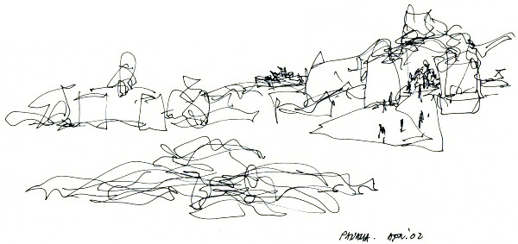

Preliminary sketches for the Panama Puente de Vida Museo | © Frank O. Gehry

- First look at the work of these architects. Choose the two that you think are the most interesting.
Shigeru Ban http://www.shigerubanarchitects.com/works.html
Zaha Hadid http://www.zaha-hadid.com/archive

Frank Gehry http://www.architecturaldigest.com/gallery/best-of-frank-gehry-slideshow/all
Frank Lloyd Wright http://franklloydwright.org/frank-lloyd-wright/
Norma Sklarek https://www.thoughtco.com/norma-merrick-sklarek-faia-177422
Not one , but a list buildings by Norwegian architects https://theculturetrip.com/europe/norway/articles/contemporary-norwegian-architecture-the-10-best-buildings-of-the-last-five-years/

I would like you to look at each source above, and I have put lots of sources on our webpage for this unit (https://visualartaba.weebly.com/unit-2-architecture.html) – you may even find some other sources about these architects in your own research.
You need to choose one building by two different architects. ( so two buildings in total)

Then you need to :
- Post an image of the building fully citing the source ( the name of the architects, the name of the building, date it was built, location of the building, and full URL of where you got the image from – in APA format is best!).
- Explain what the FUNCTION of the building is. ( is it an office block, a prison, a hospital? What is it used for?)
- Describe the materials used – if this information is available.
- Explain how the building ‘fits’ into the location (does it echo the landscape or location so it is sympathetic to the surroundings, or does it contrast with other buildings or landscape around it ,or is the location not part of the architect’s concern for the design of the building?).
- Describe the shapes, texture, colours, space, light used for each building (some people like to make drawings as part of their description to show what they have noticed, if you do this then remember to post these as well)

Once you have done this for each building you will have looked carefully at them, found out about the architect’s intentions, and what the building is used for – together this adds up to an ANALYSIS of the buildings.

You are now ready to COMPARE and CONTRAST. This basically means you will describe how the buildings are similar and how they are different.
The things you must note are:
- How are the buildings similar and different in terms of FUNCTION (what purpose are they made to be used for?)
- How is the location different/similar for each?
- How are the materials used different/similar?
- How do they look similar/different?
- If you have found information about how the architects begin to plan their work and their process you could also comment on this.

I would like all of this to be posted onto your site.

Criterion A: Knowledge and Understanding
Criterion D: Responding
Level of Achievement | Descriptor | Details
1-2 | demonstrates limited knowledge of the art form studied, including concepts, processes, and limited use of appropriate language  you present a limited critique of the artwork of self and others. | You have only a little evidence of having investigated and analysed two buildings, one from each of the architects you have selected. There is little use of art vocabulary.  Your compare/contrast work is limited and consists of noting some superficial visual qualities or is incomplete.
3-4 | demonstrates adequate knowledge of the art form studied, including concepts, processes, and adequate use of appropriate language  you present an adequate critique of the artwork of self and others. | You have evidence of having a comment for each task listed, although these are brief. There is some art and design vocabulary used.  Your compare/contrast work is adequate and you have cited sources.
5-6 | demonstrates substantial knowledge of the art form studied, including concepts, processes, and substantial use of appropriate language  you present a substantial critique of the artwork of self and others. | You have evidence of substantial, thoughtful comment for each of the tasks listed. You use subject specific vocabulary accurately .  Your compare/contrast work is substantial with fully cited sources.
7-8 | demonstrates excellent knowledge of the art form studied, including concepts, processes, and excellent use of appropriate language  you present an excellent critique of the artwork of self and others. | Your compare/contrast work is excellent, fully cited sources, thorough description/analysis using subject specific language and then a detailed and thoughtful comparison/contrast. The words ‘insightful’, thoughtful’ ‘thorough’ describe your work.

