We are going to start our ‘journey’ by exploring Collage.

Collage in the 20th century
The origins of collage can be traced back hundreds of years, but this technique made a dramatic reappearance in the early 20th century as an art form of novelty.
Cubism, Surrealism, photomontage
"The simple act of fixing scraps of printed material onto a canvas has had a profound impact on the development of Modern Art.
Picasso and Braque playfully questioned painted reality with inserts of wood grain paper and went on to develop the language of Cubism using the vocabulary of pasted papers. The Surrealists subverted the 19th scrapbook to create an hypnotic imagery of the inner mind, whilst in the form of photomontage, A very different type of cut paper was explored by Matisse who brought together the disciplines of drawing and colouring. "
Some great 20th century collage artists to look up
- Romare Bearden
- Hanna Hoch
- Kurt Schwitters
- Georges Braque
- Juan Gris
- Max Ernst
- Eduardo Paolozzi
- Peter Blake
- Tom Wessellman
- Hans Arp and the Dada collage
Dadaists describe how Arp made "chance collages" such as this one: by tearing paper into pieces, dropping them onto a larger sheet, and pasting each scrap wherever it happened to fall. The relatively ordered appearance of Arp's collages suggests, however, that the artist did not fully relinquish artistic control. Skeptical of reason in the wake of World War I, Arp and other Dadaists turned to chance as an antidote
https://www.thinkib.net/visualarts/page/9129/collage

Collage Today
Many more artists today are taking the old art form of collage into new configurations or using familiar old techniques to put forth new ideas. The practice of collage continues well beyond the 20th century and has its unique place among other art forms, sometimes drawing on the vocabulary of modernist collage but with distinctly 21st century twists.

Contemporary Collage Artists
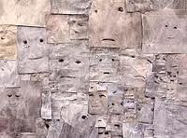
Contemporary artists working in the medium of collage use a range of material that often draws on nostalgia, but not necessarily. In Matt Bryans' collage installation, (right) the artist plasters the walls with newspaper photographs that have been erased all except for the eyes for a spooky, unnerving effect. Read more..
From The Newspaper: Matt Bryans’ drawings are produced by erasing images printed on pieces of newspaper recovered from the streets of London,
Bryans does not so much remove what is on the newspaper page as edit it. He retains some things from the original images, eliminates others altogether, and allows still others to remain as smeared, ghostly traces. Untitled, 2005, a large-scale, ziggurat-shaped wall assemblage of rectangular pieces of newspaper, consists of photographs of faces from which virtually all traces of individuality have been erased except the eyes. These peer out from eerie, mask like visages, occasionally accompanied by hints of a nose or mouth. The work’s palette is a greyish brown reminiscent of Analytical Cubism, as is its space, which is broken up into facets by the clippings’ edges. Using a simple pencil eraser Bryans converts the world’s news into a collage and speaks more pictorially of shifts in tone and colour, than of famine or murder or sporting victory. Bryans is interested in the media’s tendency to flatten an individual’s experience, and in turn figurative representation may be loosened, creating a suggestive atmosphere

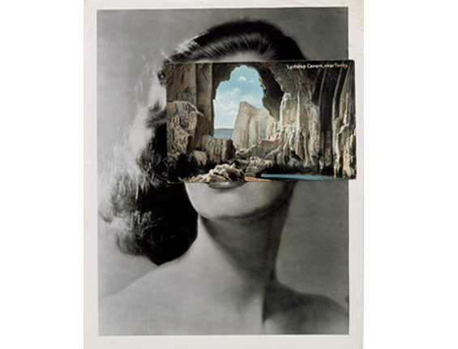
John Stezaker, makes his collage/ montage works from vintage postcards and hollywood portraits, a simple, cleverly aligned juxtaposition of two disparate images
British artist John Stezaker is fascinated by the lure of images. Taking classic movie stills, vintage postcards and book illustrations, Stezaker makes collages to give old images a new meaning. By adjusting, inverting and slicing separate pictures together to create unique new works of art, Stezaker explores the subversive force of found images. Stezaker’s famous Mask series fuses the profiles of glamorous sitters with caves, hamlets, or waterfalls, making for images of eerie beauty. From the exhibition catalogue at the Whitechapel Gallery, London.

De-collage
DE-collage is essentially reverse collage, unpeeling layers of paper. Look at the decollage posters by Mimmo Rotella. Rotella was an Italian Pop artist who drew heavily on film imagery from the 1950s and 60s and created the so-called décollages by tearing layers of film posters stuck on canvas to recreate the appearance of peeling billboards. Compare Rotella's decollages to the contemporary artist: Mark Bradford on Art 21.

Your Tasks

1.
You will need to have evidence of investigation about collage. If you completed the Grade 10 course you are already adept at this. You will need to update your website to have a ‘Grade11/IB1’ page. As we progress through the course your website will provide the material you will use to begin to build the ‘screens’ for your Process Portfolio – eventually your website will become more of a resource for gathering material and the ‘screens’ will become your main focus. For now though we will continue with the methods we have practiced in Grade 10.
https://www.youtube.com/watch?v=aX9SVg6L5vA

Nest week you will meet Joe, a young artist based in Durham in the UK. He is in his last year of a Fine Art degree and specialises in the medium of collage.
( NB: DOCUMENT ALL FIRSTHAND CONTACT WITH ARTISTS AS THOROUGHLY AS YOU CAN – these opportunities are gold dust in terms of the assessment descriptors).

He will share some of his work with you and there will be opportunities to work along-side him in the studio on Wednesday 23rd August next week after school 14.20- 16.00, and Saturday 26th August 10.00-12.00.

2.

You have been given some collage materials and a cardboard shape. These shapes fit together in a variety of ways. Your job is to make a collage on your shape, however, it must ‘join’ up with at least one other persons’, or more, shape/s. This will mean you have to plan and talk to each other.
The piece you make will be collaborative and will enable you to start to think about some of the possibilities that collage offers. There are also opportunities for thinking ‘outside the box’ and being inventive.

3.
Your brief is to create a collage using the starting concept of “ Obsession’
You have freedom to explore this idea as an individual. Your restrictions are:
- You must document your process thoroughly and be prepared to present your work and process in a group critique.
- You have freedom to choose scale, support, interpretation of the concept but the final work must be entirely or partially collage. (you may choose to have bas relief/assemblage/painted, drawn elements).
- You must be able to relate your work to one or more of the artists you have investigated.
- There is a limited time scale for this work and we will begin our group critiques/presentations the week after the Eid break.

