The grade 12 Visual Artists have 7 months to complete the 3 components required. Each is pursuing their own individual creative inquiry. The components are:
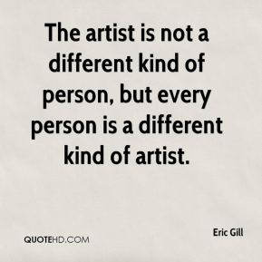
Exhibition 40%: Due March 23rd
Goal SL4-7 art works plus written requirements and exhibition photographs
HL 8-11 art works plus written requirements and exhibition photographs

Process Portfolio 40% Due January 8th
Goal SL 9-18 screens
For SL students the submitted work must be in at least two art-making forms, each from separate columns of the art-making forms table.
HL 13-25 screens
HL students submit 13–25 screens which evidence their sustained experimentation, exploration, manipulation and refinement of a variety of art-making activities. For HL students the submitted work must have been created in at least three art-making forms, selected from a minimum of two columns of the art-making forms table.

Comparative Study 20% : Due October 31st

SL 10-15 screens

HL 10-15 screens plus 3-5 screens -
Analysis and reflection on of how your work is impacted by the study (evidence of an actual art work – but the criterion is about the analysis and connection not the quality of the piece – the piece may be included in the exhibition)

COMPARE/CONTRAST Task – Analysis and Reflection

At least 3 artworks by at least 2 artists

