- Ultraclutch hairspray cans x 18
- Using evian water sprays and pringles tubes
- Needs designing - solving how to make the spray and tube fit together
- Needs to be distinctive label

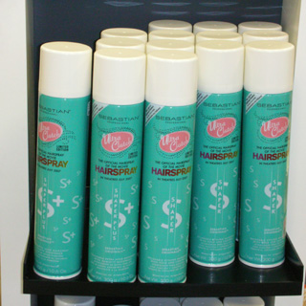

- Baltimore skyline and street props
- A painted design that can be printed in strips to cover ‘toblerones’ on stage
- Should be Baltimore landmarks/distinctive
- Road signs – US green signs saying ‘Baltimore downtown’ etc
- Stop lights
- Men at work signs – street life

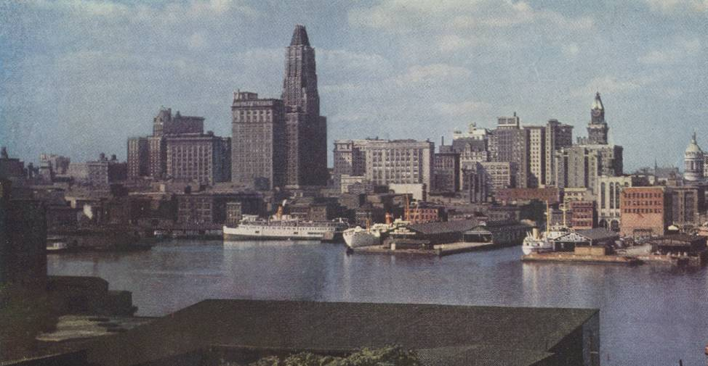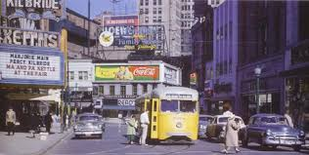
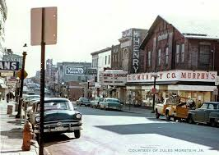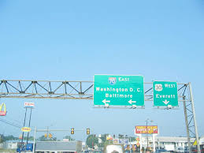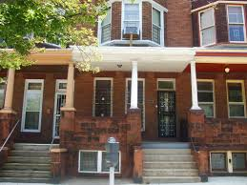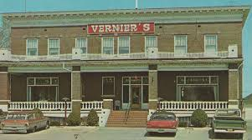

- Signs for Corny Collins show and Motormouth Mabel’s record store
- Large! Bigger than whiteboard in the art room 1….
- MM mabel – with some fluorescent paint with a ‘blacklight’
- 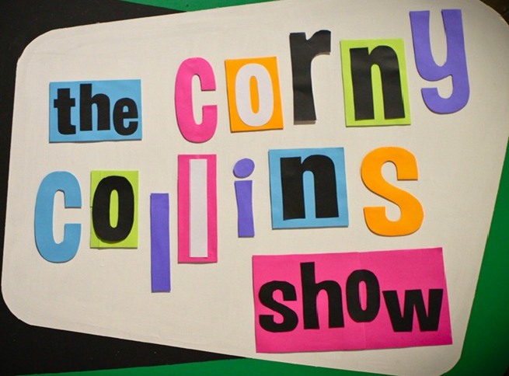
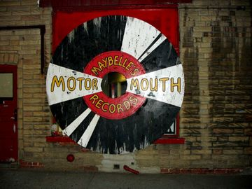

- Tracey’s bed
- Vertical! Birdseye view
- Built onto frame
- Painted
- Needs design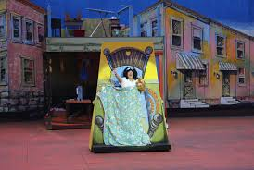

- The Turnblad frontroom and Penny’s bedroom
- ‘book’ structure so it can transform
- need to read the script for these scenes ( Mum ironing….)
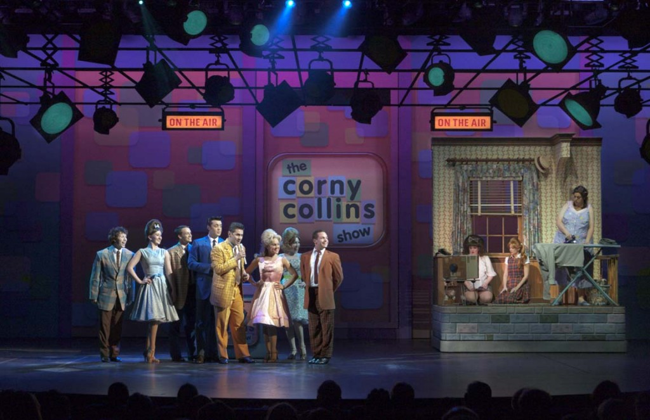
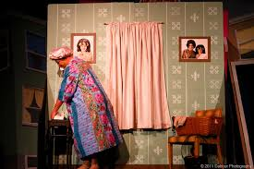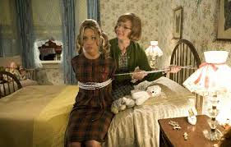

- Massive can of hairspray to hide in…..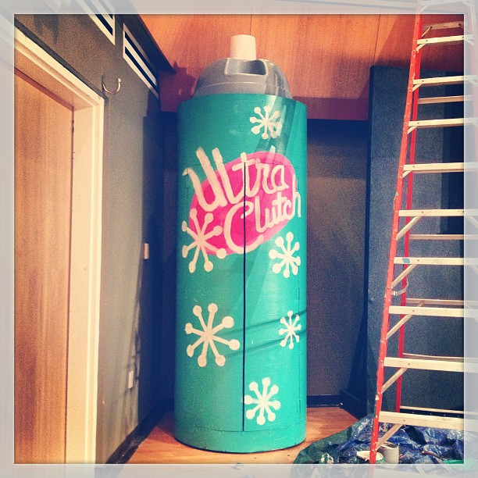

- 1960’s TV

