The Diploma Programme visual arts course has been conceived as a holistic course reflecting the dynamic nature of the visual arts. Student achievement is assessed through three distinct and independent tasks that are not accomplished directly through any one of the three core areas or three practices, but rather are informed by engagement throughout the course. These tasks should be perceived as the outcomes of a sustained, reflective, inquiry-integrated and studio-based course.

The core areas and art practices
The Visual arts guide (March 2014) prescribes a course structure that consists of syllabus content organizers that are referred to as the core areas and the art practices. Students are required to understand the relationship between these areas and how each area informs and impacts their work in visual arts. Each of these aspects of content—core areas and art practices—could be considered in its own right as well as interconnected.
The core areas provide an organizing framework for exploring why artists create and how they respond to their world, the forms and techniques involved in making works of art, as well as investigating how the presentation of works of art contributes to their meaning and significance.
The practices reinforce a creative action cycle through each of the core areas, and suggest a working methodology in which theory informs art-making practices, and in turn art-making informs theory.

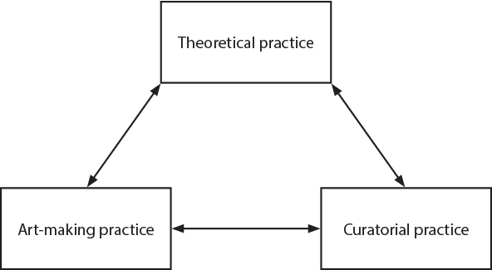
Figure 1

Engaging with theoretical, art-making and curatorial practice will affect such things as students’ interests, investigations, interpretations, intentions, decisions, actions, reflections and evaluations within the scope of the course while gaining an appreciation of the contribution that artists, historians, critics, curators and audiences make to the field of visual arts and other related creative industries.

The visual arts journal
The visual arts journal underpins every aspect of the course and reflects the holistic nature of the course. Students will use the journal, which can take many forms, to record all aspects of their art-making journey, including experiments with media, research, reflections, observations and personal responses. While the visual arts journal is not directly assessed or monitored, aspects of it may be drawn upon to complete aspects of the assessment tasks. Artists and artworks that students may have investigated to inform their art-making, for example, may become the subject of the comparative study task. Alternatively, media experiments undertaken in the journal might become part of the process portfolio task.

Assessment weightings
Comparative study (external assessment task) 20%
Dominant core area: visual arts in context
Dominant art-making practice: theoretical practice
Process portfolio (external assessment task) 40%
Dominant core area: visual arts methods
Dominant art-making practice: art-making practice
Exhibition (internal assessment task) 40%
Dominant core area: communicating visual arts
Dominant art-making practice: curatorial practice

Working in more than one art-making form
Throughout the course students are expected to experience working with a variety of different art-making and conceptual forms. This becomes of critical importance in the process portfolio assessment task where marks are capped if students have not met the minimum requirement.

Year 1 of the Visual Art course 2017/18 in Brief
Teacher: Mr. Keys

August –October

3 mini-units focusing on concepts, techniques and artists to reinforce the connection with TOK, to ensure our Process Portfolio is ‘fueled’ by our journal practice, to ensure we have at least three art making forms from at least two of the art making forms table columns (not as complicated as it sounds!).
Assessed using descriptors relevant to experiment and development
NB: Journal can be in sketchbook or electronic form and all students keep a website as online portfolio.

November

Visiting artist – workshops and project. Visit to Art Abu Dhabi.

Exhibition of Work to Date
Curatorial practice – in school event, student directed Art Show of all work so far

December

Compare and Contrast – preparation for Comparative Study, understanding the criteria

January – March

Comparative Study - planning and writing component worth 20% of final grade.
Jan-Feb: research and writing CS, Feb-March making artwork in response to the CS.

Comparative Studies displayed during the Gr 12 exam exhibition.

Using IB2 Exam Exhibition as learning tool – marking against criteria

April – June

Process Portfolio – goal of having 10 slides completed.
Beginning the individual art practice that will lead to the exam exhibition in year 2 – establishing broad artistic concerns/themes.
Preparing for summer work.
Assessed against Process Portfolio descriptors.

