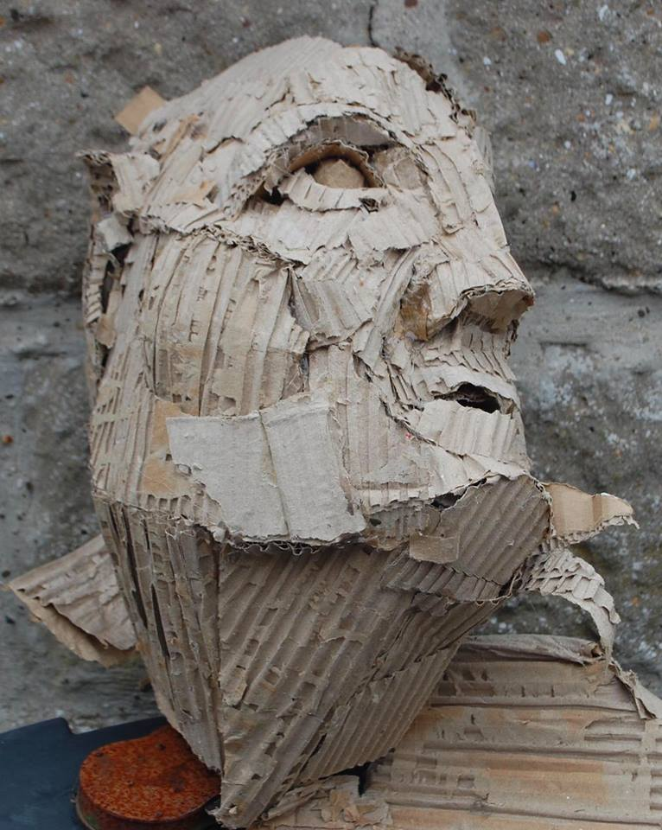
Saul Cumiskey is an inspiring artist and teacher. I have known him for many years, having been fortunate to have him be my mentor whilst undertaking my final Teaching Practice during my Post Graduate teacher training. I have followed his career closely over the years, both as an artist and educator, and continue to learn from him. I am very excited he has agreed to spend time with our ABA art students! As well conducting one to one critiques with our Grade 12 artists Saul will share his work and process with some of our classes and offer a weekend workshop.
Details of how to sign up for the workshop will follow in due course.
Richard Keys

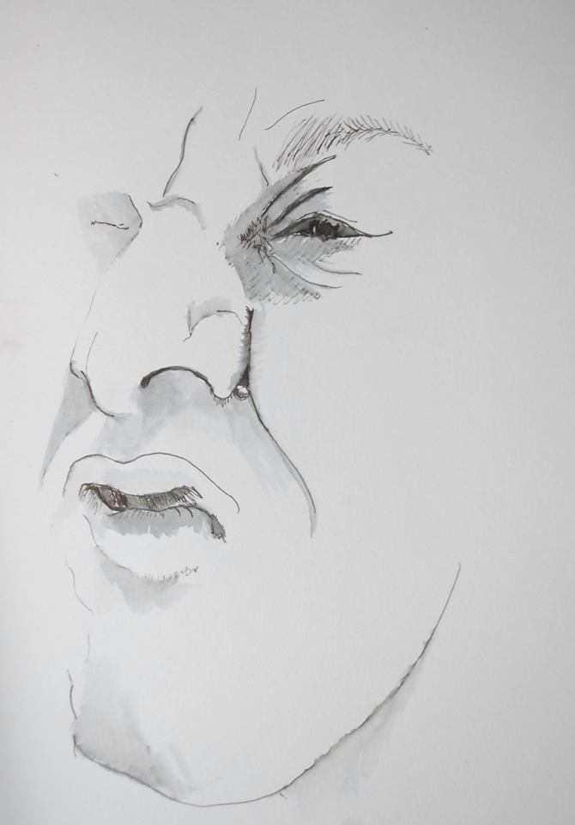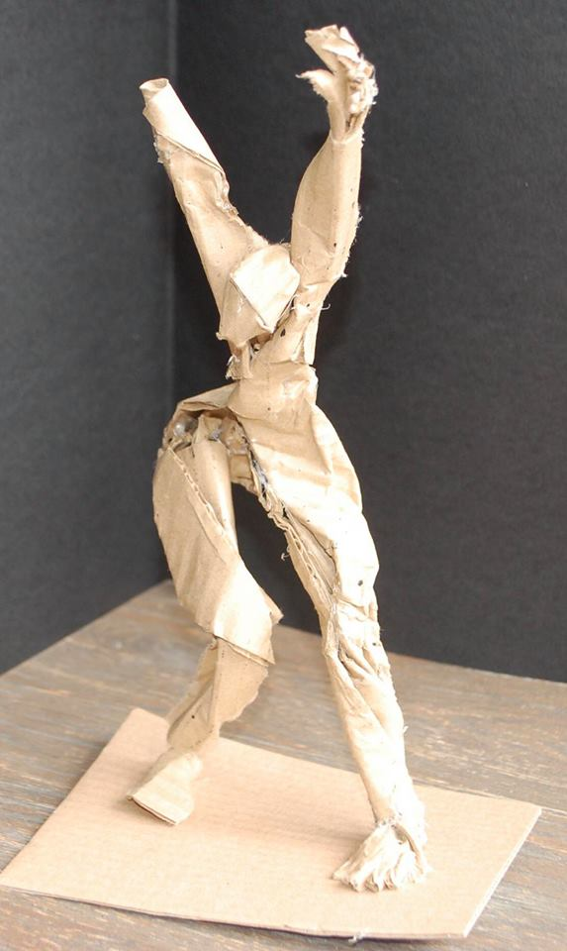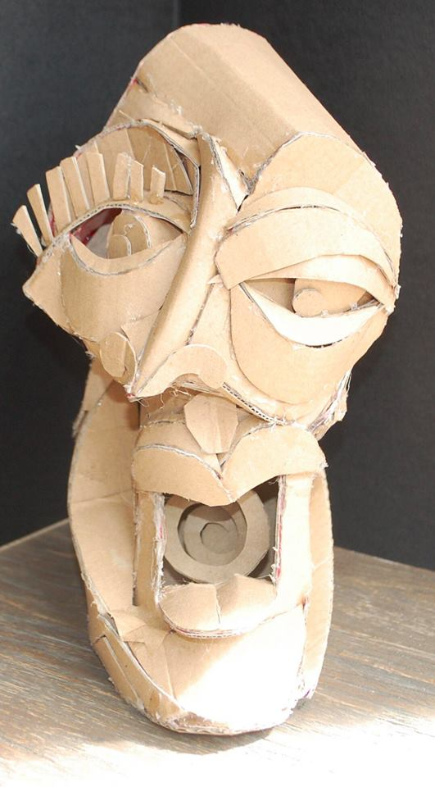

Saul Cumiskey: Biography

Having graduated as a sculptor from St.Martin’s College of Art and Design in the mid 1980’s I had many opportunities to exhibit sculpture in London both in group and one man shows. This led to invitations to exhibit in Australia and I spent a happy 3 years in Melbourne both showing work and producing pieces for commissions. During this period my work shifted in focus from the three dimensional to drawing. My sculptural process had always involved drawing but now these drawings became the focus of my inquiry in themselves.

Returning to the UK I completed a Post Graduate teaching qualification and taught Secondary Art and Design for several years in Reading in Berkshire. This in turn led to a stint working in the Art and Design Education Department at the University of Reading working with students studying for PGCE and BA Ed qualifications.

A move to Kidderminster resulted in my working in a Further Education Art College teaching Btec Foundation Art, alongside GNVQ and GCSE qualifications, eventually becoming Head of Department. In the year 2000 we moved once more to Devon where I worked in a local Secondary school, and began to exhibit my own art again. Having then left teaching to pursue my own work full time I was asked to work as Senior Teacher in a local school that provides education for young people with Social, Emotional and mental Health needs.
At present I am once again leaving teaching to work full time in the studio, but as I do so I reflect on how teaching has paralleled and in some ways driven my own learning.

