Introduction to the subject from the current guide:

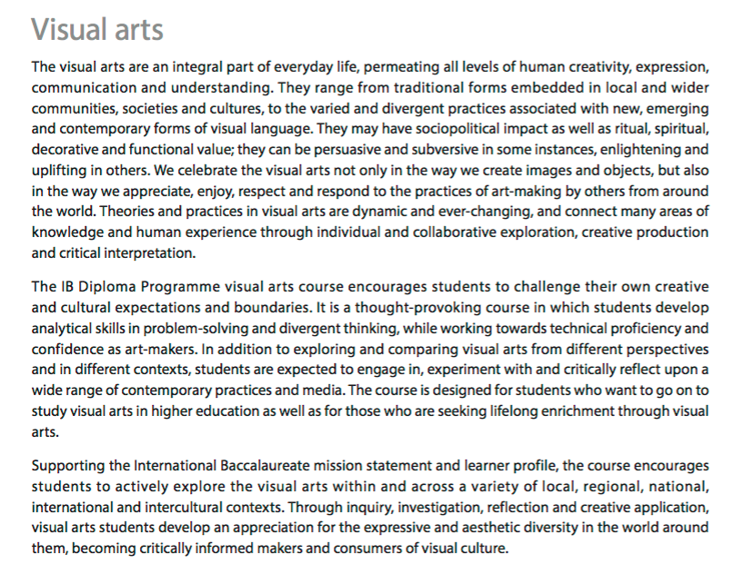
http://occ.ibo.org/ibis/occ/Utils/getFile2.cfm?source=/ibis/occ/home/subjectHome.cfm&filename=dSpace%2Fen%2Fd%5F6%5Fvisar%5Fgui%5F1702%5F1%5Fe%2Epdf
Students of the arts subjects study the various artistic ways through which knowledge, skills and attitudes from different cultural contexts are developed and transmitted. These subjects allow students to investigate and reflect on the complexities of the human condition. By exploring a range of materials and technologies, students should aim to develop an understanding of the technical, creative, expressive and communicative aspects of the arts.
Students of the arts subjects have the opportunity to analyse artistic knowledge from various perspectives, and they acquire this knowledge through experiential means as well as more traditional academic methods. The nature of the arts is such that an exploration of the areas of knowledge in general, and knowledge of the different art forms specifically, can combine to help us understand ourselves, our patterns of behaviour and our relationship to each other and our wider environment.
The arts subjects complement the TOK ethos by revealing interdisciplinary connections and allowing students to explore the strengths and limitations of individual and cultural perspectives. Studying the arts requires students to reflect on and question their own bases of knowledge. In addition, by exploring other Diploma Programme subjects with an artistic bias, students can gain an understanding of the interdependent nature of knowledge through which they are encouraged to become, “active, compassionate and lifelong learners who understand that other people, with their differences, can also be right” (IB mission statement).
28 Visual arts guide

In John Carey’s ‘What good are the Arts?’ many arguments and claims for the value of the arts are critiqued – this review from The Guardian newspaper is a good summary of the main points: https://www.theguardian.com/books/2005/jun/11/highereducation.news
There is another, maybe clearer review of the ideas here: http://researchonline.nd.edu.au/cgi/viewcontent.cgi?article=1007&context=arts_article

From “why art cannot be taught” James Elkins

