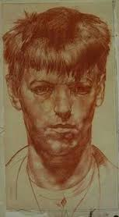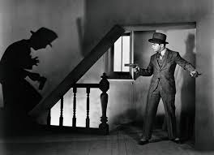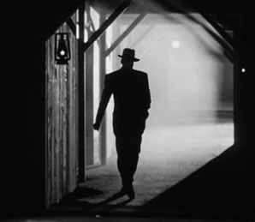

**Unit 4: 6 Steps to Success- how to approach thematic projects.**

* Opportunity to apply acquired skills in a more individual way.
* Structure for sustaining a creative inquiry.

**Unit 3: The Edge – land/sea- land /sky**

* Investigating landscape Art.
* Local field trip to gather observation source material.
* Collagraph print making
* Photography, drawing, painting.

**Unit 2: ‘Stories and Stereotypes’-**

**Film Noir**

* Exploring the genre of Film Noir.
* Examining the use of stereotypes in these films and then our own possible assumptions about others.
* Planning a narrative based on this self knowledge and using Film Noir tropes to make an art piece.
* Seeking ways of make time based work without using lens-based media (using unconventional media and electrical circuits).

Image: <http://athenscine.com/filmnoirseries.php>

**Unit 1: ‘Looks Like’ versus ‘Is like’**

* Focus on portraiture skills and concepts
* Subjective and objective approaches to portraiture.
* Using contextual knowledge to gain a more accurate ‘reading’ of art works
* Drawing, photography and painting.
* Website, art journal, personal engagement – organizational skills. Presentation skills.
* Writing/communicating intentions and reflecting on process and development.

Image: Stanley Spencer Self Portrait

<http://pictify.saatchigallery.com/377193/stanley->

spencer-self-portrait